

Guidance Document for Circol ELT

CSV Reporting

eQF237 - Version 2.0
Date 16/02/2023

CSV File Return
This guidance document is intended to help members report to Circol ELT using a .CSV file upload. If you have any questions after reading through this document, please call the Circol ELT team on (01) 4618 600 or email us at info@Circolelt.ie and we will help you with any queries you may have.

Getting Started:
Open the ‘Blank CSV template’ file – please request this from Circol ELT Membership Team if you do not already have it.

This is where the main reporting data is inputted.
Note: Please ensure each category correctly completed in order for the CSV file to upload successfully
Member:
Enter your four-digit Circol ELT member number for each line of your report, e.g., 1418
Period:
Enter the month you are reporting for in the following format ‘yyyymm’, e.g., 201801
Note: You will require a separate file for each monthly reporting period.
Activity Type:
There are four activity types:
1 = Purchases
2 = Fitted (Tyres bought elsewhere and your business fits to customers vehicle)
3 = Sales
4 = Collections
Choose the relevant activity which you wish to report, e.g., 1
Tyre Type:
Choose your tyre type from the full list provided in Appendix A on the last page of this document.
Example: For ‘Passenger Car/Van/4x4’ tyres enter 12
14 | Motorcycle Tyres
 | Part Worn/Used Agri Tyres
 | Part Worn/Used Car Tyres
12 | Passenger Car/Van/4x4
 | Retreads - Truck/Bus
13.2 | Truck/Bus - Heavy
13.1 | Truck/Bus - Light Commercial
Note: You must submit the correct applicable sub-categories, e.g. 13.1, 13.2, 15.11, 15.12, etc.
Unique ID:
1 = Purchases
When entering a supplier (Activity Type = 1) you will need their ‘Unique ID’.
This Unique ID number can be found on the on our website.
Note: You will need to open a new web page to look up the Unique ID number on the Member’s list as it cannot be searched for while logged into the reporting portal.
If your supplier is not listed, please contact info@Circolelt.ie.
2 = Fitted (Tyres bought elsewhere and your business fits to customers vehicle)
For any tyres which you only fit for customer there is no unique ID available, and so, this unique ID field will be left blank.
Note: If you have zero tyres in this category then this activity type may be omitted from your reporting.
3 = Sales
When entering sales to a trade customer (B2B) you will find their unique id number on the Members List as shown above. Again, if your customer is not listed, please contact info@Circolelt.ie.
For any tyres which you may sell to the General Public (B2C) please use the Unique ID ‘5961344’.
Any tyres that may be sold as Export Sales should simply use the generic code ‘2’.
4 = Collections
Please enter the code for your collector who takes your waste tyres.
This is in the format of ‘xxxx’, (e.g., 1011,1012) and can be obtained from the Collectors List on our website.
Quantity:
Enter number of tyres Purchased, fitted (Not sold by you), Sold or Collected, e.g. 405

Saving the report file:
Once all the above steps have been completed, we should have a fully completed file. Save this file in .CSV format as shown below
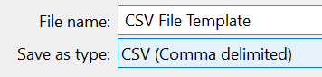
Note: Please ensure there are no extra columns or excess data as this may lead to issues with the successful submission of your file.

Example of a completed CSV File:
Member | Period | Activity Type | Tyre Type | Unique ID | Quantity
1418 | 201801 | 1 | 12 | 815123 | 405
1418 | 201801 | 1 | 12 | 1234167 | 321
1418 | 201801 | 1 | 14 | 2145332 | 22
1418 | 201801 | 2 | 12 |  | 32
1418 | 201801 | 3 | 12 | 5961344 | 640
1418 | 201801 | 3 | 12 | 2 | 40
1418 | 201801 | 3 | 12 | 923665 | 16
1418 | 201801 | 4 | 12 | 1011 | 430
1418 | 201801 | 4 | 12 | 1012 | 224

When you click ‘Save As’, the below message will appear. Click on ‘Yes’.
(It is important that there is no formatting in the CSV file in order for the file to upload successfully.)
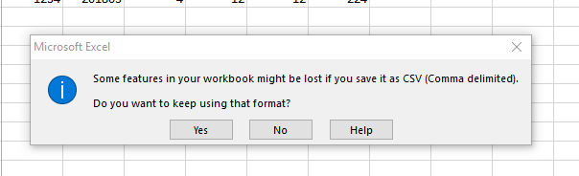

Uploading your .CSV file:
When clicking on the ‘Returns’ tab you will be presented with a list of reporting returns which are due/overdue.
Directly below, at the bottom of the page, you will have an alternative option to upload your .CSV file.
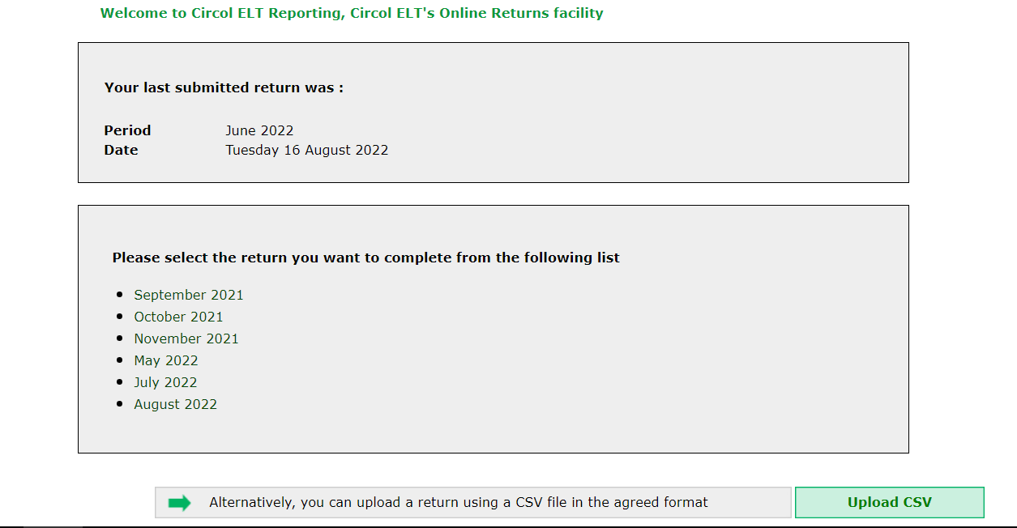
Click on ‘Upload CSV’…

Select your CSV file with the details of your returns from your computer by clicking on the Choose File button:
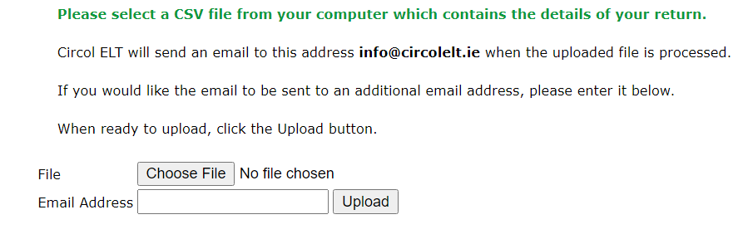

Once file has been selected, click on upload:
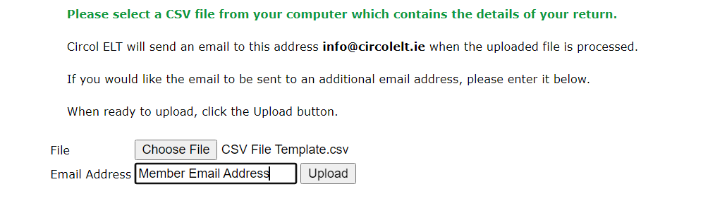

The following message will appear when you have successfully uploaded your CSV file:


NOTE – The above message indicates that the file has been successfully sent to Circol ELT. If there are any issues with the data supplied in the CSV file, a member of Circol ELT Membership Team will be in contact with you so the file can be rectified and resubmitted.

Appendix A

Tyre Types:
Code | Tyre Type
12 | Passenger Car/Van/4x4
13.1 | Truck/Bus - Light Commercial
13.2 | Truck/Bus - Heavy
 | Part Worn/Used Agri Tyres
 | Part Worn/Used Car Tyres
 | Retreads - Truck/Bus
14 | Motorcycle Tyres
15.1 | Agri Implement 0-5kgs
15.10 | Agri Tractor 41-110kgs (24/26/28/30' Tractor Tyres
15.11 | Agri Tractor 111-150kgs (34' Tractor Tyre)
15.12 | Agri Tractor 151-250kgs (38' Tractor Tyres)
15.13 | Agri Tractor 251-400kgs (42' Tractor Tyres)
15.14 | Agri Tractor 401+kgs
15.2 | Agri Implement 6-20kgs
15.3 | Agri Implement 20.1-40kgs
15.4 | Agri Implement 41-70kgs
15.5 | Agri Implement 71-110kgs
15.6 | Agri Implement 111-150kgs
15.7 | Agri Implement 151-200kgs
15.8 | Agri Implement 201-400kgs
15.9 | Agri Tractor 10-40kgs (Front Wheel 2WD Tractor)
16.1 | Construction 0-100kgs (EM 17.5 R25 Dump Truck)
16.2 | Construction 100-300kgs (EM 23.5 R25 Dump Truck)
16.3 | Construction 301-400kgs (EM 26.5 R25 Dump Truck)
16.4 | Construction 401-500kgs (EM 29.5 R25 Dump Truck)
16.5 | Construction 501-600kgs (Earthmover 2400-R35)
16.6 | Construction 601-900kgs (Earthmover 45-65-R45)
16.7 | Construction 901kgs
17.1 | Industrial Pneumatic 21' - 25'
17.1 | Industrial Solid 0 < 8'
17.2 | Industrial Solid 8' <=12'
17.3 | Industrial Solid 15' - 16'
17.4 | Industrial Solid 20'
17.5 | Industrial Solid 21' < 25'
17.6 | Industrial Pneumatic 0 < 8'
17.7 | Industrial Pneumatic 8' <= 12'
17.8 | Industrial Pneumatic 15' - 16'
17.9 | Industrial Pneumatic 20'

